🔥 Day 19 — DNS Caching (Why changes don’t reflect)
Today’s goal:
👉 Understand why DNS changes don’t update immediately
👉 Learn how to verify + bypass cache

1️⃣ Check DNS with dig
Run:
dig google.com
Focus on:
ANSWER SECTION:
google.com. 300 IN A 142.250.x.x

💡 Important:
300 = TTL (Time To Live)
👉 This means:
DNS result is cached for 300 seconds (5 min)

2️⃣ Test Cache Behavior
Run twice:
dig google.com
Second time is usually:
👉 Faster
Why?
Cached result used

3️⃣ 🔥 Compare Different DNS Servers
Run:
dig google.com @8.8.8.8
dig google.com @1.1.1.1

Observe:
- Same domain
- Possibly different IPs
- Different response times
👉 This proves:
DNS is distributed system

4️⃣ 🔥 Real Scenario: “DNS Changed but Not Working”
Simulate confusion:

Step 1: Add fake entry
sudo vi /etc/hosts
Add:
1.2.3.4 google.com

Step 2: Test
ping google.com
👉 Uses wrong IP

Step 3: Remove entry
Delete that line

Step 4: Test again
ping google.com
👉 Sometimes still behaves weird for few seconds

💡 Why?
Caching / resolution delay

5️⃣ Clear Cache (if service exists)
Check:
systemctl status systemd-resolved
If active:
sudo systemctl restart systemd-resolved

6️⃣ Advanced Check (Very Important)
Run:
dig +trace google.com

What this shows:
Step-by-step resolution:
Root servers
→ TLD (.com)
→ Authoritative server
→ Final IP
👉 This is actual DNS flow

7️⃣ Key Understanding
Today’s biggest learning:
DNS is NOT instant
DNS uses caching (TTL)
Different systems may see different results temporarily

🧠 What You Must Write Today
TTL Meaning
Time DNS result is cached

Key Insight
DNS changes are not immediate due to caching

Important Commands
dig
dig @server
dig +trace

Real Scenario
Website updated but still showing old IP → DNS cache issue

✅ Expected Output (Day 19)
You should have:
✔ Checked TTL
✔ Compared multiple DNS servers
✔ Understood caching behavior
✔ Used dig +trace
✔ Simulated DNS confusion

Step 1: Inspect the TTL (Time To Live)
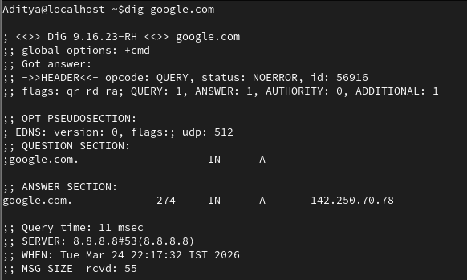

Step 1: Check DNS with dig (Inspect TTL)
Command:
dig google.com
What to observe in the ANSWER SECTION:
google.com. 274 IN A 142.250.70.78
- 274 = TTL (Time To Live) in seconds
- Meaning: The DNS result is cached for 274 seconds (~4.5 min). Until TTL expires, the same cached IP is returned without querying the DNS server again.

2️⃣ Test Cache Behavior
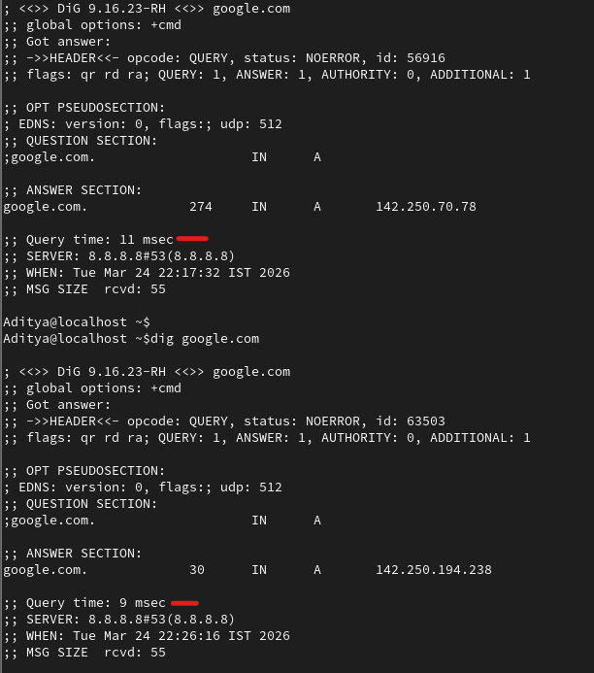
Step 2: Test Cache Behavior
Run dig google.com twice back-to-back.
Run | TTL | Query Time | IP
1st | 274 | 11 msec | 142.250.70.78
2nd | 30 | 9 msec | 142.250.194.238
Observation: Second query is faster because the result was served from cache. TTL decreases between queries.
Step 3: Compare DNS Providers
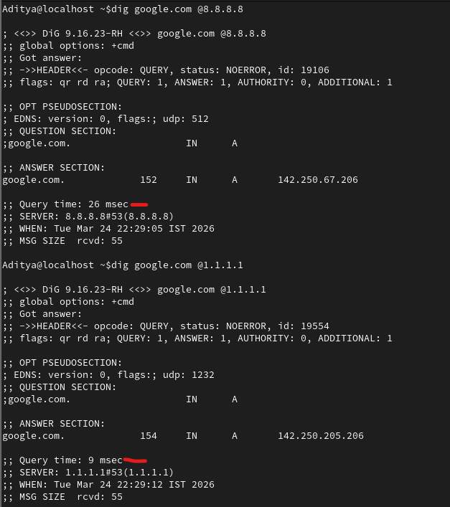

Step 3: Compare Different DNS Servers
Commands:
dig google.com @8.8.8.8 (Google DNS)
dig google.com @1.1.1.1 (Cloudflare DNS)
Observations:
DNS Server | IP Returned | TTL | Query Time
8.8.8.8 (Google) | 142.250.67.206 | 152 | 26 msec
1.1.1.1 (Cloudflare) | 142.250.205.206 | 154 | 9 msec
Key Takeaway: Same domain can return different IPs and different response times from different DNS providers. This proves DNS is a distributed system.

Step 4: Simulate "DNS Confusion" (The /etc/hosts trick)
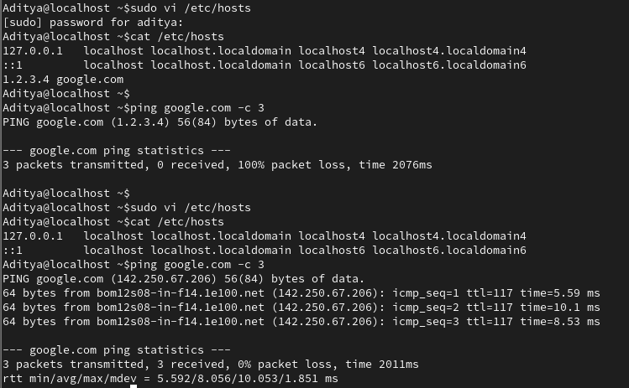
Step 4: Simulate "DNS Confusion" (The /etc/hosts Trick)
4a. Add a fake entry:
sudo vi /etc/hosts
Add this line:
1.2.3.4 google.com
4b. Test with ping:
ping google.com -c 3
Result: Pings 1.2.3.4 → 100% packet loss (wrong IP, unreachable)
4c. Remove the fake entry:
sudo vi /etc/hosts
Delete the 1.2.3.4 google.com line.
4d. Test again:
ping google.com -c 3
Result: Pings 142.250.67.206 → all 3 packets received ✅
Why this matters: /etc/hosts overrides DNS resolution locally. This simulates what happens when DNS records change but old cached entries persist.
Step 5: Trace the "Real" Path
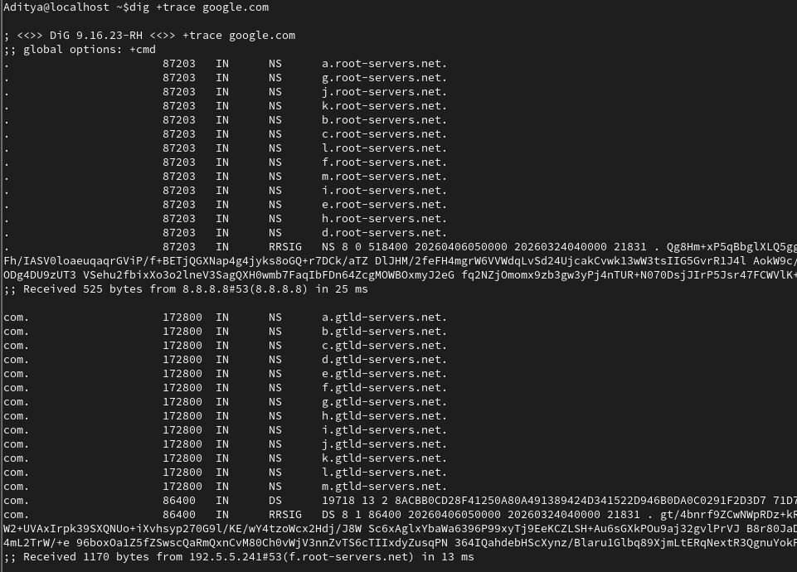
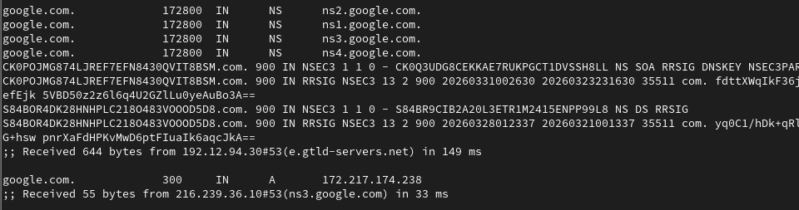
Step 5: Trace the Full DNS Resolution Path
Command:
dig +trace google.com
What this shows (step-by-step resolution):
- Root Servers (.) → directs to .com TLD servers (e.g., f.root-servers.net)
- TLD Servers (.com) → directs to Google's nameservers (e.g., e.gtld-servers.net)
- Authoritative NS (ns3.google.com) → returns final IP: 172.217.174.238
This is the actual DNS resolution flow — Root → TLD → Authoritative → Answer.
Step 6: Flush the Cache
sudo systemctl reload NetworkManager.service
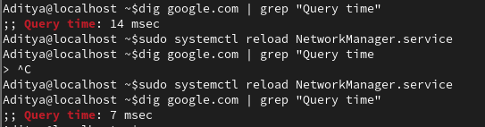
Step 6: Flush/Clear DNS Cache
Command:
sudo systemctl reload NetworkManager.service
Verify:
dig google.com | grep "Query time"
- Before flush: 14 msec (cached)
- After flush: 7 msec (fresh resolution)

📘 Day 19 — DNS Caching (Why DNS Changes Don't Reflect Immediately)
🎯 Objective
- Understand why DNS changes don't update immediately
- Learn how to verify and bypass DNS cache

📝 Key Concepts Summary
Concept | Explanation
TTL | Time (in seconds) a DNS result stays cached
DNS Caching | DNS results are stored locally to speed up future queries
Why changes aren't instant | Old cached results persist until TTL expires
/etc/hosts | Local file that overrides DNS; checked before DNS query
dig +trace | Shows complete DNS resolution path: Root → TLD → Authoritative
🔧 Important Commands
Command | Purpose
dig google.com | Query DNS and check TTL
dig google.com @8.8.8.8 | Query using a specific DNS server
dig +trace google.com | Trace full resolution path
sudo vi /etc/hosts | Edit local DNS overrides
sudo systemctl reload NetworkManager.service | Flush DNS cache
💡 Real-World Scenario
"I updated my website's DNS record but it still shows the old IP!" Answer: DNS caching. The old TTL hasn't expired yet. Wait for TTL to expire, or flush your local DNS cache.

